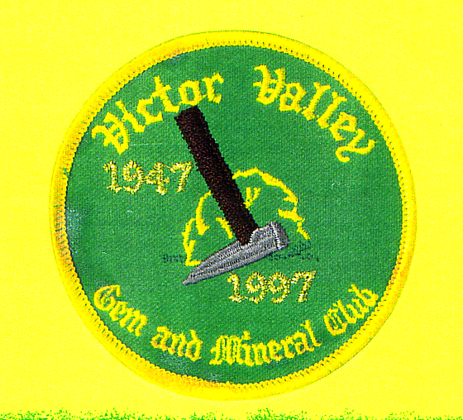

Victor Valley

Gem & Mineral Club
760-243-2330

Roster of Members

January 2005
Roster of Members

January 2005
New Members List

